1. LT6911x uses IIC to burn, and must use USB to IIC tools

Search for "CH341T module USB to 12C" on Taobao to find this module.

2. After installing the USB to IIC tool and driver, there is this device in the device manager, and the driver can be provided by the Taobao store owner

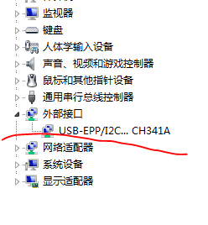

3. Connect the development board and module according to the "SDA", "SCL" and "GND" line sequence of the IIC bus. Power up the module (3.3V).

4. Open the burning tool "LT1605_I2C2SPI_V2_100k.exe" (extracted from the LT1605_download_tool.rar), select the flashing code, click "Flash", and wait for the burning to be successful.

